University Of Engineering and Technology, Lahore
Computer Engineering Department

Course Name: Programming Fundamentals | Course Code: CMPE-112L
Assignment Type: Lab Tasks | Dated: 23-03-2026
Semester: 1st | Session: Spring
Lab/Project/Assignment #: 4 | CLOs to be covered: CLO 1
Lab Title: Nested Loop | Teacher Name: Hafiz Muhammad Mubashar
Lab Evaluation:

CLO1 | Apply appropriate programming techniques to create executable programs to solve well defined problems
 | Level1 | Level2 | Level3 | Level4 | Level5 | Level6
(5)
Total |  |  |  |  |  | /5
Rubrics for Current Lab Evaluation
Scale | Marks | Level | Rubric
Excellent | 5 | L1 | Submitted all lab tasks, BONUS task, have good understanding.
Very Good | 4 | L2 | Submitted the lab tasks but have good understanding
Good | 3 | L3 | Submitted the lab tasks but have weak understanding.
Basic | 2 | L4 | Submitted the lab tasks but have no understanding.
Barely Acceptable | 1 | L5 | Submitted only one lab task.
Not Acceptable | 0 | L6 | Did not attempt
LAB No 4
Lab Goals/Objectives:
To learn nested loops in Python and use them for patterns, tables, calculations, and problem solving.
Equipment Required:
Computer or Laptop, Python 3.x, PyCharm or VS Code.
Theory:
Nested loops are loops inside another loop. They are used for patterns, tables, and repeated operations involving rows and columns.
Lab Work:

Task 1: Calculate marks, average, and grade for multiple students.
Result:
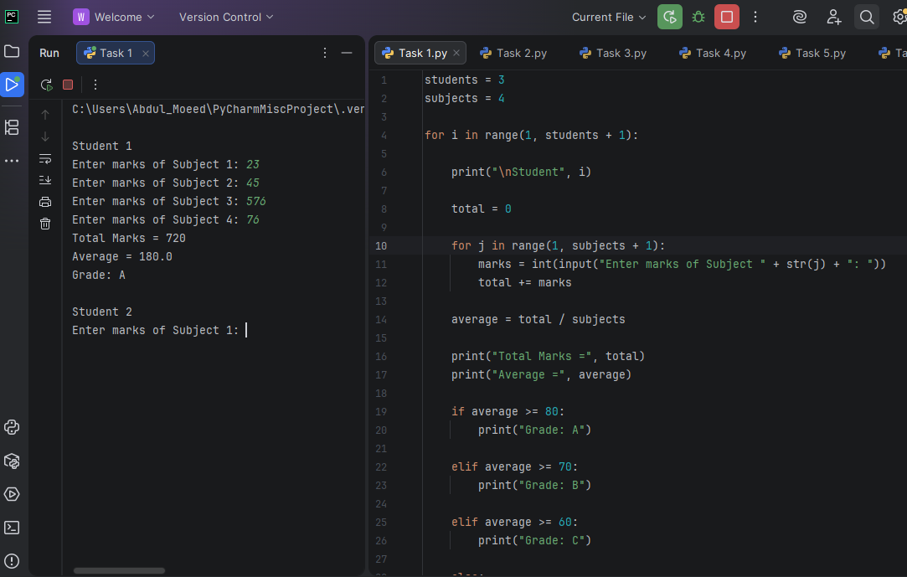
Task 2: Print a diamond star pattern.
Result:
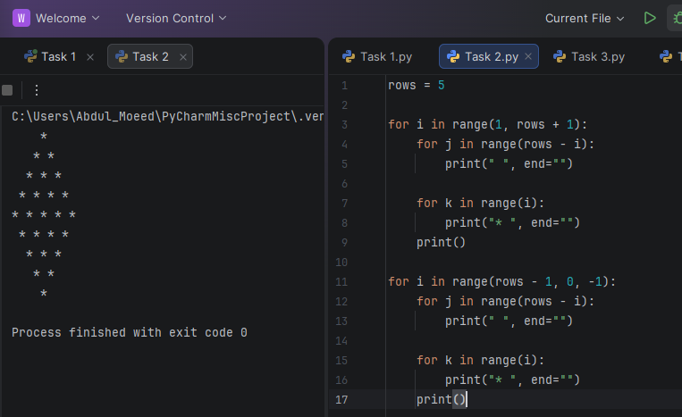
Task 3: Print multiplication tables from 1 to 3.
Result: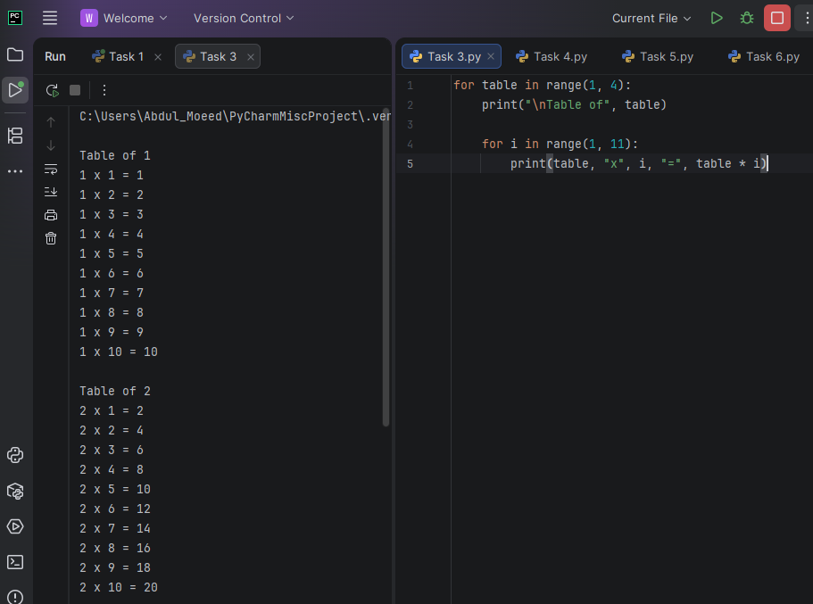
Task 4: Print a right triangle star pattern.
Result: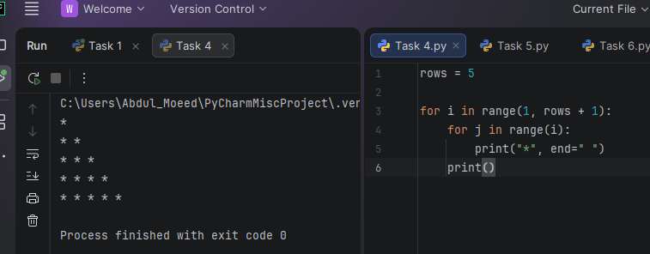

Task 5: Print a number triangle pattern.
Result: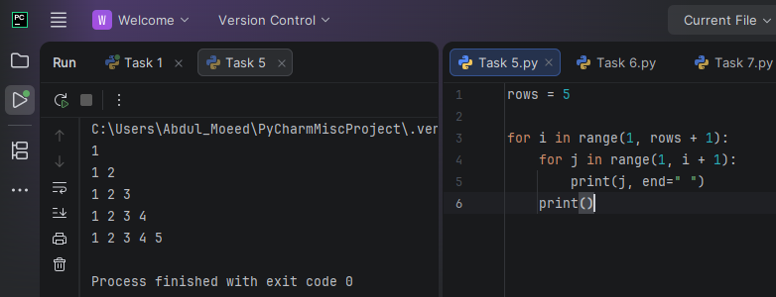

Task 6: Display prime numbers from 2 to 20.
Result: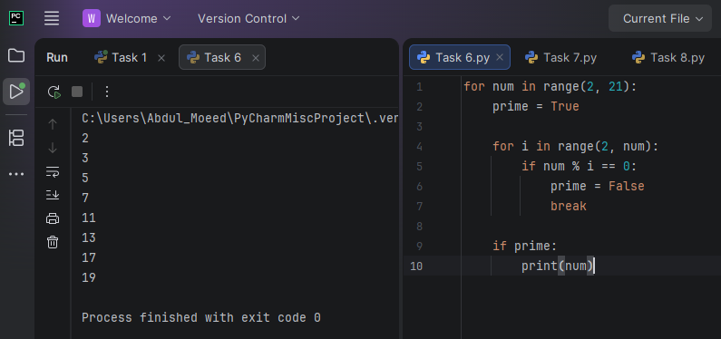

Task 7: Calculate total and average marks for students.
Result:
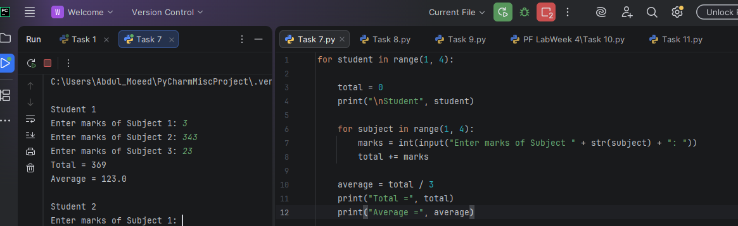
Task 8: Print a hollow rectangle pattern.
Result:
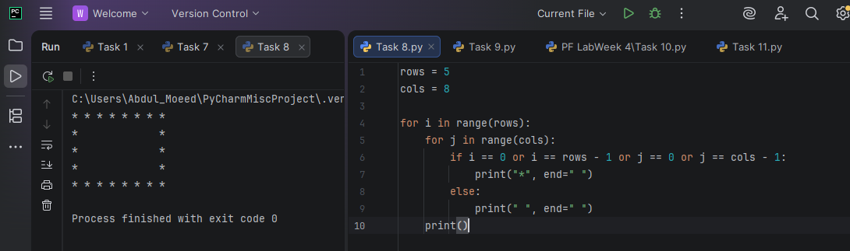
Task 9: Calculate the total bill for multiple customers.
Result: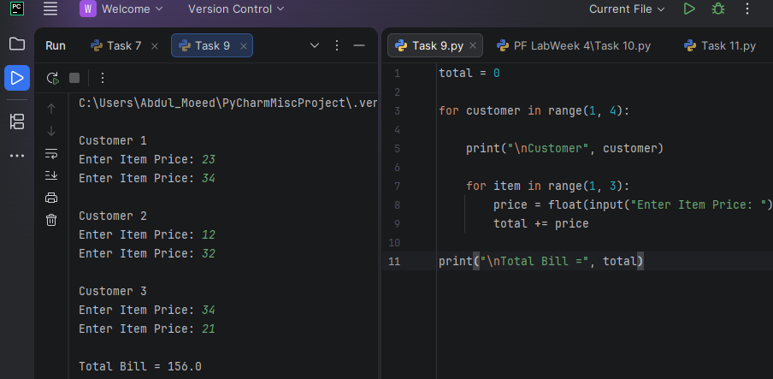

Task 10: Print a checkerboard pattern.
Result: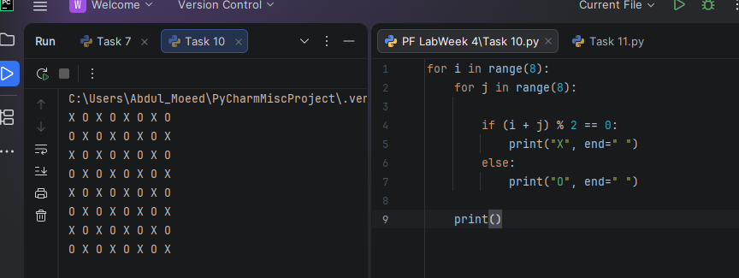

Task 11: Create a login system with three password attempts.
Result:
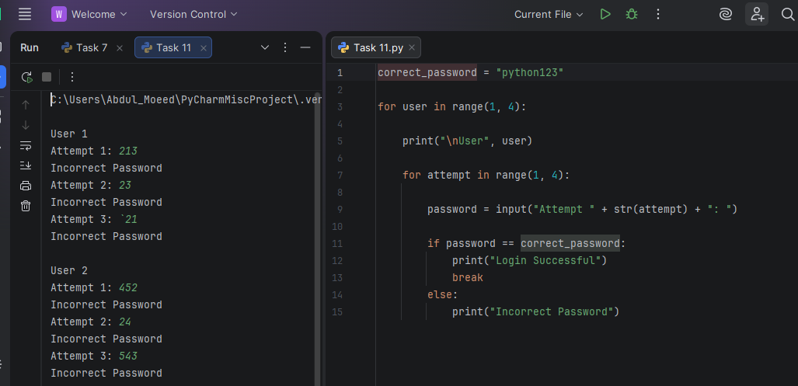

Conclusion:
The lab improved understanding of nested loops and their use in patterns, tables, calculations, and user-based programs.

